MCT333s (UG2018) - Mechatronic Systems Design


TEAM 2
APEX



Nouran Mohamed Hassan | 2200122
Heba Rabea Teleb | 2200428
Mohammed Ibrahim | 2200286
Malak sherif | 2200376
Fady Ramy Adel | 2200811
Hanan Mohamed Soliman | 2200391

Table Of Contents
1. Software and Vision System Design 2
1.1 System Overview 2
1.2 Hardware Platform 2
1.3 Wi-Fi Setup 3
1.4 Camera Initialization 3
1.5 QR Code Detection Algorithm 4
1.6 Real-Time Task Architecture 4
1.7 Wireless Communication 5

Table Of Figures
Figure 1: Scanned QR 1 6
Figure 2 :Scanned QR 2 6

1. Software and Vision System Design

1.1 System Overview
The perception subsystem of the robot is responsible for detecting and decoding QR codes placed on the competition cubes. The decoded data indicates the target color of the box, which determines the correct delivery location.
According to the competition rules, each cube contains a QR code encoding the color (Red, Blue, or Green) which must be read by the robot before the sorting and delivery process.
To implement this functionality, an ESP32-S3 Cam module with an integrated GC2145 2-MP camera sensor was used. The ESP32 handles:
- Image acquisition
- QR code detection
- Wireless streaming
- Communication with the operator interface
The system processes camera frames in real time and decodes QR codes using the Quirc QR-code recognition library.
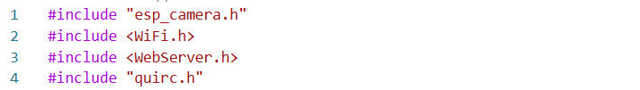

1.2 Hardware Platform
The vision system uses:
Microcontroller
- ESP32-S3 CAM
Camera Sensor
- 2 MP GC2145
CPU
- Dual-core 32-bit ESP32-S3
RAM
- 520 KB internal + 8 MB PSRAM

Communication
- WiFi Access Point mode
The external PSRAM is particularly important because it allows buffering multiple camera frames and improves streaming performance.

1.3 Wi-Fi Setup
ESP32-CAM operates in Access Point (AP) mode.
Users connect via mobile or PC to the AP (SSID: ESPCAM, Password: 12345678).
Two web endpoints are served:
- Port 80: Web dashboard with QR code results and control.
- Port 81: Raw video streaming for live monitoring.
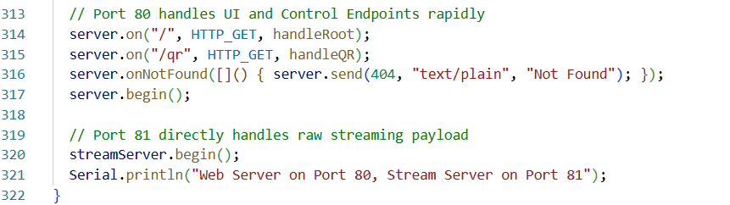

1.4 Camera Initialization
The ESP32 camera is configured to capture grayscale frames at QVGA resolution (320×240).
This configuration is chosen because:
- Lower resolution increases processing speed
- Grayscale reduces memory usage
- Improves QR detection reliability
Code – Camera Configuration

If PSRAM is detected, the system allocates two frame buffers to increase performance.
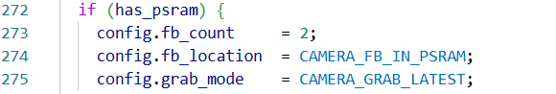

1.5 QR Code Detection Algorithm
QR decoding is implemented using the Quirc library, which is optimized for embedded systems.
The algorithm works as follows:
- Capture camera frame
- Resize QR decoder buffer
- Copy frame into the decoder
- Detect QR patterns
- Decode payload

1.6 Real-Time Task Architecture
The system uses FreeRTOS multitasking, which allows the ESP32 to run multiple operations simultaneously.
Two main tasks run in parallel:
Task 1 – QR Detection Task
Runs on Core 0.
Responsibilities:
- Capture frames
- Decode QR codes
- Store the detected result
Task 2 – Streaming Task
Runs in the main loop.
Responsibilities:
- Send live video to the browser
- Provide monitoring interface

1.7 Wireless Communication
The ESP32 operates in Access Point (AP) mode.

Users connect directly to the robot and open the web dashboard.
Dashboard Features
- Live camera feed
- QR detection results
- FPS monitoring
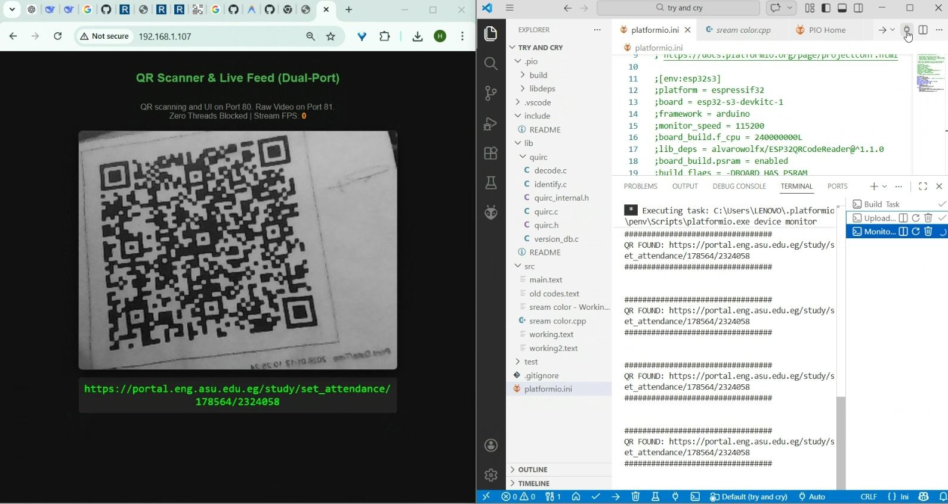
Figure 1: Scanned QR 1
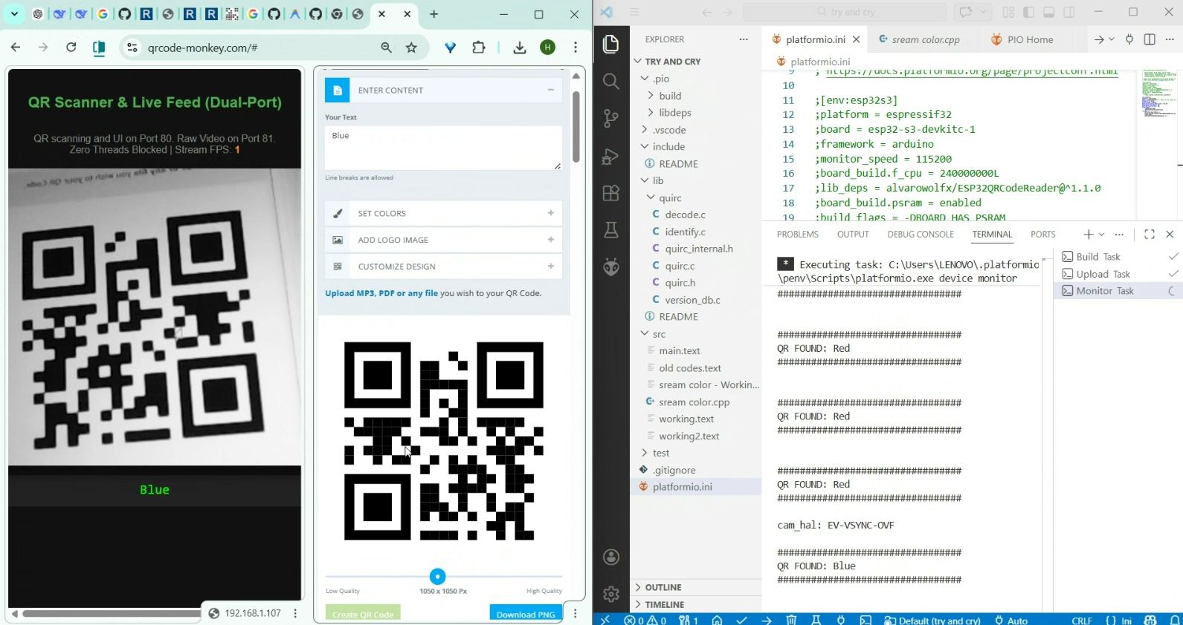
Figure 2:Scanned QR 2

